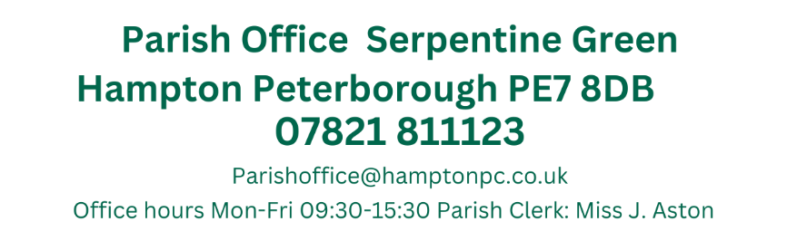
Present: Councillors, Antunes, T. Fields, Guyton, Z. O’Sullivan, Patel, Pratt, Ryan, Toynton-Ward (Chair) & Wiggin.

5th September 2024
19:15
Active Hampton, Beaumont Way

MEETING OF THE PARISH COUNCIL
Members 13/14 (Quorum 5) Meeting was open to members of the public.
MINUTES
061/09-2024  19:15 | To receive apologies of absence
061/09-2024  19:15 | Apologies received from Cllrs H. Fields, Otim, B. O’Sullivan and Sharp
062/09-2024  19:16 | Declarations of disclosable pecuniary interest.
062/09-2024  19:16 | Cllrs Patel and Ryan both declared an interest in Agenda item 072/09-2024  As members of the Active Hampton Committee.
063/09-2024  19:17 | Public Forum
063/09-2024  19:17 | No members of the public were present
064/09-2024  19:32 | Ward Councillors Forum
064/09-2024  19:32 | Cllr Wiggin stated the Council is starting back up after the summer break, The local plan is currently subject to change due to new government and he will be briefed at the next full council meeting.  The S151 officer has resigned and a new finance officer will be appointed  Cllr Antunes stated that Cllr Boyce is the Parish Liaison officer and has been voted to represent at a national level. The Draft Parish Council liaison document is in progress and Cllr Boyce would be available to attend a Parish meeting to discuss this.  Cllr Antunes is also working with the NHS and met with members of the community to discuss accessing services in the area, specifically ooking at preventative methods such as depression and hypertension.
065/09-2024 | Approval of Minutes
065/09-2024 | Those who were present received and approved the minutes of the last meeting held on the 11th July 2024 and the 8th August  July: Present: Antunes, H. Fields, T. Fields, Otim, B. O’Sullivan, Z. O’Sullivan Patel, Pratt, Ryan, Sharp, Toynton-Ward (Chair) & Wiggin.  Proposed by Cllr Toynton-Ward and seconded by Cllr Ryan  August: Present: Antunes, H. Fields, T. Fields, B O’Sullivan, Z O’Sullivan, Wiggin (Chair)  Proposed by Cllr Wiggin and Seconded by Cllr O’Sullivan
066/09-2024  19:45 | Wildflower Planting
066/09-2024  19:45 | Councillor Antunes discussed his plans for wildflower planting in Hampton.  representative from PECS was also present to discuss the plans and the Parish involvement in this  Cllr Antunes met with Highways and Anglia water to discuss the plans for the wildflower planting on Natures way. The total cost of this would be between £4400 and £5500.  Regarding the plans near the memorial garden the anticipated cost of this would be between £10,000 and £13,000, however Councillors are concerned that this would attract anti-social behaviours and would receive complaints from local residents.  Cllr Antunes will discuss the plans with other stakeholders regarding part funding/sponsorship and will discuss with the Clerk, the plans for a public consultation.
067/09-2024  20:05 | Planning Applications
067/09-2024  20:05 | Members to comment on the following:  Cllr Antunes will abstain from voting on any application due to him sitting on the PCC Planning Committee.  Existing use of a 6no bedroom HMO  55 Molyneux Square Hampton Vale Peterborough PE7 8WA  Ref. No: 24/00729/CLE | Validated: Fri 02 Aug 2024 | Status: Awaiting decision  No comments made (due to the nature of the parking, it was not felt that the Parish Council had grounds to object)  Erection of two-storey annexe to Premier Inn, alterations to the car park and associated works  4 Ashbourne Road Hampton Centre Peterborough PE7 8BT  Ref. No: 24/01087/FUL | Validated: Thu 22 Aug 2024 | Status: Awaiting decision  No comments made  Garage conversion to annex (part-retrospective)  85 Buckthorn Road Hampton Hargate Peterborough PE7 8GB  Ref. No: 24/01045/HHFUL | Validated: Wed 07 Aug 2024 | Status: Awaiting decision  No comments made
068/09-2024  20:15 | Planning Application Outcomes
068/09-2024  20:15 | To note:  Change of Use from C3 (residential dwelling) to C2 (residential institution) for up to 2 children (aged 12-18)  3 Hornbeam Road Hampton Hargate Peterborough PE7 8FY  Ref. No: 24/00804/FUL | Validated: Thu 20 Jun 2024 | Status: Decided  Withdrawn by applicated/Objected
069/09-2024  20:17 | Approval of Accounts
069/09-2024  20:17 | Members approved the following payments:  Petty Cash Items over £50.00  *Items were purchased on behalf of Ward Councillor Wiggin’s Community Leadership Funding and will be refunded  Stones & Garden - £352.99 Memorial Garden Stones  Amazon - £176.02 (Membrane, pegs and Strimmer)  Amazon £49.99 Wheelbarrow  Stones & Garden - £382.99 Memorial Garden Stones  TLC Signs £174.00 -Serpentine Green notice board  Proposed by Cllr Pratt and Seconded by Cllr Wiggin
  JA00687 | 4045 | Nest Pension | No date assigned | DD | £106.93
  JA00688 | 4000 | J. Aston  Clerks Salary | ASAP | BACS | £1,706.44
  JA00689 | 4040 | HMRC Tax & NI  Contributions | ASA | BACS | £457.91
  JA00690 | 4055 | Lengthsmen x2 (Peterborough Ltd) | ASAP | BACS | £6,123.46
  JA00691 |  | Petty Cash | 02/08/2024 | BACS (Preapproved) | £650.00*
  JA00692 |  | Petty Cash | 02/08/2024 | BACS  (Preapproved) | £400.00*
  TOTAL – Excluding Pre-approved items |  |  |  |  | £8394.74
070/09-2024  20:20 | Hampton Bulky Waste Collection
070/09-2024  20:20 | The next collection will be held on the 7th September.  Members formalised the dates and stated that a WhatsApp group would be formed with attending Councillors  Volunteers at each site will be  Active Hampton Cllr Patel & Cllr Wiggin  Hargate Allotment Cllr H.Fields & Cllr T. Fields  Hampton Library Cllr Ryan & Cllr Sharp  Vale Allotments Cllr O’Sullivan
071/09-2024  20:25 | Meeting Arrangements
071/09-2024  20:25 | As the Councill now has 13 members, the meeting table has become particularly cramped, and a vote was taken to purchase an additional 2 tables to ensure that all Councillors have the space required at meetings.  Two 1600W x 800D x 725H mm tables, identical to ones previously purchased for the meeting room would cost £544.80 (inc VAT)  Members voted with the majority in favour of purchasing two tables
072/09-2024  20:30 | Public Space Protection Orders
072/09-2024  20:30 | Cllr B. O’Sullivan suggested that a PSPO on all open spaces would be of benefit within the Parish.  PSPO’s can be introduced to reduce Anti-social behaviours and help to deal with a particular nuisance or problem in a particular area that is damaging to the local community’s quality of life.  They set out specific conditions on how an area can be used, such as specifying that all dogs must be on leads etc.  The application needs to list activities that have taken place that have had a detrimental effect on the quality of life of those in the locality, or it is likely that activities will take place and that they will have a detrimental effect Public spaces protection orders: guidance for councils (local.gov.uk)  Members felt that a PSPO, although worthwhile would be difficult to enforce and that the Parish Council should engage with the public regarding keeping dogs on leads near children’s play areas, the Sports field, Molyneux Square and Stanford Square.
073/09-2024  20:45 | Councillor Conduct
073/09-2024  20:45 | Members are to note the following.  - All Councillors are to be reminded that as a Parish Councillor, unless a project or topic is delegated by the Council and minuted as such, then you should not be carrying out meetings on behalf of the Parish Council.  - Members are also reminded to declare any interests PRIOR to the meeting  - Any item that you wish to be discussed by the Parish Council should be communicated to the Clerk in the first instance, at least 3 days prior to the agenda being disseminated  If you require further guidance on any of these matters please consult the Good Councillors guide The Good Councillor’s guide 2024 (nalc.gov.uk)  or the Clerk
074/09-2024  20:50 | Items for future agendas
074/09-2024  20:50 | 2024 Financial Regulations – Oct FC  HV/HAA Plan – Oct FC
075/09-2024  20:52 | HVCC
075/09-2024  20:52 | Due to the confidential nature of this agenda item, members of the public will be asked to leave during this agenda item.  Public Bodies (Admission to Meetings) Act 1960 1. (2)  Members requested to invite PCC Officer to a future meeting.
076/09-2024  21:05 | Clerks Report
076/09-2024  21:05 | Councillor Training  A training session provided by the PCC to assist Parish Councillors and Co-opted Members with code of conduct issues and register of interests, will be held on Thursday, 26 September 2024 from 5:30pm. A number of Councillors have already signed up to this and if you wish to attend, please let me know.  Lengthsmen Meeting  I have had a meeting with the HH and HV Lengthsmen and Manager regarding comments made on social media. This applied to the open spaces around Hampton which O&H are responsible for.  It was then decided that the public need to be more aware of which areas the Parish lengthsmen are responsible for via social media and a QR code on their barrows which will link to the Parish website.  I have asked for photos of bags collected to highlight this on social media.  I also have a map of all PCC bins in the Parish although a particular issue has been highlighted that any bins purchased by Councillors for public use are not emptied by PCC as there is no ownership in place and Aragon are not paid to empty these.  The HH lengthsman will also not be removing any litter collected from litter picks, and this will be collected the following Monday by PCC from the bus shelter in Hargate Centre.  Stewartby Avenue One Way System  I have sent an attachment for HV Primary school to disseminate to parents on their next email newsletter regarding the One way system  PES Officer  C. George is on annual leave until the 18th September and will provide an update on the Parish request of an PES officer overtime working.  Speed Signage Data  Unfortunately due to the high winds and bad weather I have not been able to download the Vale speed sign Data. This will be sent either tomorrow or Tuesday  The Hargate sign is temperamental and needs another investigation as to why the battery is draining so quickly  Hampton in Action  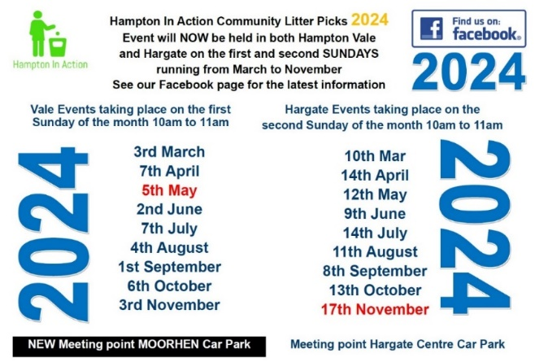
Close of Meeting 21:15

