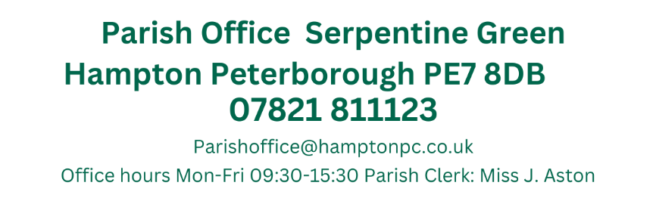
Dear Councillors Antunes, H. Fields, T. Fields, Guyton, Otim, B. O’Sullivan, Z. O’Sullivan Patel, Pratt, Ryan, Sharp, Toynton-Ward (Chair) & Wiggin. You are summoned to attend the Annual Meeting of Hampton Parish Council, which has been convened to consider and resolve the business set out below:

3rd October 2024
19:15
Active Hampton, Beaumont Way

MEETING OF THE PARISH COUNCIL
Members 13/14 (Quorum 5) Meeting is open to members of the public.
MINUTES
077/10-2024  19:15 | To receive apologies of absence
077/10-2024  19:15 | Cllrs H. Fields, Patel, Pratt and Toynton-Ward
078/10-2024  19:16 | Declarations of disclosable pecuniary interest or other registered interests
078/10-2024  19:16 | No declarations of Interest regarding items on the agenda were received.
079/10-2024  080/10-2024  19:17 | Public Forum
079/10-2024  080/10-2024  19:17 | Cllr Neil Boyce (Parish Liaison Group) was present to discuss the Parish liaison group meetings to discuss the local plan. Cllr Boyce discussed the areas where the additional housing could be built.
081/10-2024  19:32 | Ward Councillors Forum
081/10-2024  19:32 | Ward Councillor Antunes discussed his plans for the wildflower projects which had the support of Highways, Anglian Water and O&H in principle. Natures Way and an Orchard were muted. Cllr Antunes will be holding additional meetings with stakeholders. He confirmed he had attended the Combined Authority O&S Committee meeting and the Budget Working Group. He had planning Committee and Audit and the Council were reviewing budgets closely.
082/10-2024  19:42 | Approval of Minutes
082/10-2024  19:42 | Those who were present to receive and approve the minutes of the last meeting held on the 5th September  Present: Councillors, Antunes, T. Fields, Guyton, Z. O’Sullivan, Patel, Pratt, Ryan, Toynton-Ward (Chair) & Wiggin.  Proposed by Ryan and seconded by Cllr Z. O’Sullivan
083/10-2024  19:45 | HV/HAA Plans
083/10-2024  19:45 | N. Minter (HAA) was present to discuss the request to implement a fish farm on the flooded plots of 27-28 at Hampton Vale Allotments.  This will include secure pond areas formed from the current ditches and include a raised embankment to the rear of the plot  Members discussed this with the HV Chair present and it was decided that Mr Minter could work the ground and see how this affects the water on site over the winter period, each new process of work will be assessed to ensure that the impact on the site is minimal.
084/10-2024  20:00 | Planning Applications
084/10-2024  20:00 | Members commented on the following:  Installation of an air source heat pump  31 West Water Crescent Hampton Vale Peterborough PE7 8LT  Ref. No: 24/01247/HHFUL | Validated: Tue 24 Sep 2024 | Status: Awaiting decision  Non Material amendment (alter the wording of C2) to planning permission 97/00853/REM  Unit 21 The Serpentine Green Shopping Centre Hampton Centre Peterborough PE7 8BE  Ref. No: 24/01236/NONMAT | Validated: Fri 20 Sep 2024 | Status: Awaiting decision  No comments made on either application
085/10-2024  20:10 | Planning Application Outcomes
085/10-2024  20:10 | To note:  Erection of covered veranda (part-retrospective)  37 Mid Water Crescent Hampton Vale Peterborough PE7 8JT  Ref. No: 24/00953/HHFUL | Validated: Tue 23 Jul 2024 | Status: Decided  No comments made/Granted  Existing use of a 6no bedroom HMO  55 Molyneux Square Hampton Vale Peterborough PE7 8WA  Ref. No: 24/00729/CLE | Validated: Fri 02 Aug 2024 | Status: Decided  No comments made/Lawful
086/10-2024  20:12 | Approval of Accounts
086/10-2024  20:12 | Members approved the following payments:  Petty Cash Items over £50.00  Equip4work 12/09/2024  Meeting tables for Active Hampton £544.80  Amazon 24/09/2024 (Sept 24 FGP)  4 x Bodycams purchased for HAA £472.00  4 x memory cards £30.36  Total - £502.36 (£401.88 after VAT is deducted)  Proposed by Cllr Fields and seconded by Cllr Z. O’Sullivan
  JA00693 | 4045 | Nest Pension | No date assigned | DD | £106.93
  JA00694 | 4000 | J. Aston  Clerks Salary | ASAP | BACS | £1,706.44
  JA00695 | 4040 | HMRC Tax & NI  Contributions | ASA | BACS | £457.91
  JA00696 | 4055 | Lengthsmen x2 (Peterborough Ltd) | ASAP | BACS | £6,123.46
  JA00697 |  | Petty Cash | 01/09/2024 | BACS (Preapproved) | £300.00
  JA00698 |  | Petty Cash | 15/09/2024 | BACS  (Preapproved) | £600.00
  JA00699 |  | Petty Cash | 24/09/2024 | BACS  (Preapproved) | £450.00
  JA00700 |  | Petty Cash | 24/09/2024 | BACS  (Preapproved) | £200.00
  TOTAL – Excluding Pre-approved items |  |  |  |  | £8394.74
087/10-2024  20:15 | CSK Grant Request
087/10-2024  20:15 | Hampton Parish Councillors have voted to provided a grant of £4500.00 to assist with the Christmas hampers provided by CSK Church.  The hampers are provided to 75 people living in the area (nominated by the local schools, social workers and community groups) and any surplus funds are used to help to run the CSK pantry that offers a foodbank scheme to local residents who require food items.  This year they will also be sending Christmas cards to all recipients and would like HPC to be featured on this.  Cllr Sharp requested to check the level of payment made in previous years after it had been stated the amount requested here was the same as before. Deferred to check.
088/10-2024  20:25 | Financial Regulations
088/10-2024  20:25 | Clerk presented the amended Financial Regulations.  Passages that have been amended are highlighted.  Members requested that this be discussed at the next F&GP Meeting.
089/10-2024  20:30 | Councillor Conduct
089/10-2024  20:30 | Clerk updated members on the Councillor Conduct training. The slides are available on the Councillor log in page. The Clerk noted that it was disappointing that only Cllr Patel attended this meeting.
090/10-2024  20:40 | Items for future agendas
090/10-2024  20:40 | Precept Discussions – Oct FGP  Recreations Meeting – 6th November  Wildflower Planting TBC  Financial Regulations F&GP
091/10-2024  20:42 | Clerks Report
091/10-2024  20:42 | Hampton Vale One-way system  Peter Tebb (PCC) has contacted me to state that they will be issuing the invoice for the one way way system  Remembrance Day Services  Plans were only received after the agenda was posted – This will be delegated to the October F&GP for any decisions.  The wreath has been ordered and should be delivered within the next week.  Local Plan  Councillor Guyton and I attended a planning meeting to discuss the changes to the local plan. The major changes are an increase in the proposed number of dwellings from 936 per year to 1068 a year with a minimum requirement of 22,428 dwellings by 2044.  The updated Local Plan to include the need for social rented homes, compared to current priority for first homes  A Published list of any proposed sites will be available in mid-October 2024 and comments from Parish Councils by end of November 2024  The consultation on the draft Local Plan, scheduled for September and October 2024 is paused until February 2025. This will allow the necessary time to incorporate any changes to national policy, review site selection work and will ensure the evidence base is up to date  Hampton in Action
Close of Meeting 21:09
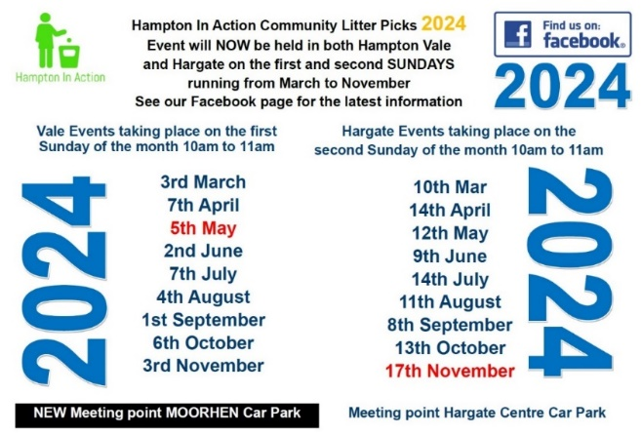

Signed:__________________________________________________Date:______________
………….Chair of approving meeting

