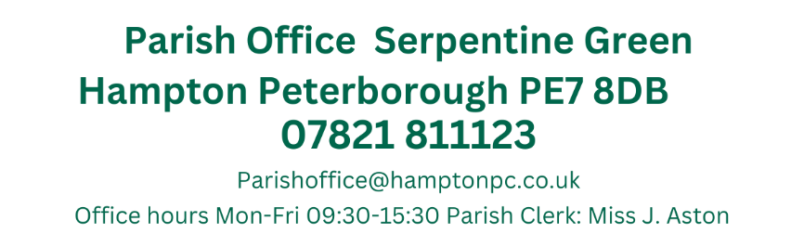
Dear T. Fields, Guyton, Otim, O’Sullivan, Patel, Pratt, Ryan, Sharp, Toynton-Ward (Chair) & Wiggin. You are summoned to attend the Annual Meeting of Hampton Parish Council, which has been convened to consider and resolve the business set out below:

18:30-1915
Members of the Public were invited to attend the
Parish Meeting of the Electorate
Overview of the 2023-2024 year by the Chair
Questions from Members of the Public
Refreshments
-Close-
9th May 2024
19:15
Active Hampton, Beaumont Way

ANNUAL MEETING OF THE PARISH COUNCIL
Members 10/14 (Quorum 5) Meeting is open to members of the public.
MINUTES
001/05-2024  19:15 | Election of Parish Chair
001/05-2024  19:15 | The Clerk led the process for elections, asking if any members wished to nominate themselves as the Chair. Cllr Toynton-Ward nominated herself for the forthcoming year.  Proposed by Cllr Pratt and Seconded by Cllr Patel
002/05-2024  19:20 | Election of Vice Chair
002/05-2024  19:20 | Cllr Wiggin nominated himself for the position of Vice Chair.  Proposed by Cllr Patel and Seconded by Cllr O’Sullivan
003/05-2024  19:25 | Co-option of Parish Councillors
003/05-2024  19:25 | Candidates Mrs Fields and Mr O’Sullivan introduced themselves and answered questions from the Parish Councillors.  Mrs Fields – Enjoyed being involved on the Parish Council  Brendan O’Sullivan Back in Peterborough and can now commit himself to the Parish Council as he did previously.  Cllr Fields and Cllr O’Sullivan both left the room whilst discussions took place  Cllrs H. Fields and Cllr B. O’Sullivan were both co-opted onto the Parish Council
004/05-2024  19:40 | To receive apologies of absence
004/05-2024  19:40 | Cllr Otim sent her apologies
005/05-2024  19:41 | Declarations of disclosable pecuniary interest.
005/05-2024  19:41 | Interests were previously declared in agenda item 003/05-2024 by Cllrs T. Fields and Z. O’Sullivan.
006/05-2024  19:42 | Public Forum
006/05-2024  19:42 | No members of the public were present
007/05-2024  19:57 | Ward Councillors Forum
007/05-2024  19:57 | Cllr Atunes Stated that he has lived in the area for a number of years and hopes he can connect the Council and the Parish Council together and is looking forward to meeting with residents.  Cllr Wiggin – Lot of changes due to the elections, still in negotiations regarding the City Council as it is NOC. Cllr Wiggin also sent his Congratulations to Cllr Farooq and Commiserations to Cllr Sharp and thank you to Nicole Truss  There will be a vote on the 20th regarding leaderships and committees
008/05-2024  20:07 | Approval of Minutes
008/05-2024  20:07 | Those who were present received and approved the minutes of the last meeting held on the 4th April.  Present: Cllrs Otim, Patel, Ryan, Sharp, Toynton-Ward (Chair) & Wiggin.  Proposed by Cllr Ryan seconded by Cllr Patel
009/05-2024  20:08 | Meeting dates
009/05-2024  20:08 | Members confirmed the meeting dates of the Full Council and Finance & General-Purpose Committee.  Members will continue to meet on the 1st Thursday of each month for the Full Council and the 3rd Thursday of each month for the F&GP Committee.
010/05-2024  20:12 | Recreations Working Party
010/05-2024  20:12 | All Members agreed to a proposal to disband the Recreations sub-committee and instead introduce a Recreations Working Party.  The Clerk will report directly to the Full Council and/or F&GP Committee and any decisions made by the Parish Council will be reported back to the Working party.  All Councillors may attend and there would be no quorate.
011/05-2024  20:20 | To appoint the nine members of the Finance and General Purposes Committee
011/05-2024  20:20 | The Finance and General Purposes Committee normally meets 9 times a year. Meetings are not held when there is insufficient Parish Council business to discuss.  Confirmed Members:  Cllr Patel  Cllr Pratt  Cllr Wiggin  Cllr Ryan  Cllr T Fields  Cllr Z. O’Sullivan  Cllr K. Toynton-Ward  Cllr L. Sharp  Cllr B O’Sullivan
012/05-2024  20:25 | To appoint the five members of the Human Resources Committee
012/05-2024  20:25 | The Sub-Committee meets no more than 4 times per year.  Confirmed Members:  Cllr Patel  Cllr Pratt  Cllr H. Fields  Cllr C Guyton
013/05-2024  20:30 | To appoint members of the Parish Liaison group
013/05-2024  20:30 | Members meet with other Parish Councils and Peterborough City Council, usually on a 2-3 a year basis.  Confirmed Members:  Cllr T. Fields  Cllr Wiggin
014/05-2024  20:35 | Planning Applications
014/05-2024  20:35 | Members commented on the following:  Engineering operations to provide a Circulatory road to facilitate the drive-through use of the existing class use E(B) premises  Unit 3 Cygnet Road Cygnet Park Hampton Peterborough PE7 8FD  Ref. No: 24/00557/FUL | Validated: Mon 29 Apr 2024 | Status: Awaiting decision  No comments  Demolition of conservatories and replace with rear ground and first floor extensions  8 Willow Holt Hampton Hargate Peterborough PE7 8AP  Ref. No: 24/00529/HHFUL | Validated: Mon 22 Apr 2024 | Status: Awaiting decision  No objections
015/05-2024  20:45 | Planning Application Outcomes
015/05-2024  20:45 | To note:  Construction of a 3m rear extension, change of door to window at the front and change of use from 3no bedroom house (Class C3) to a 6no bedroom HMO (Class C4).  35 Molyneux Square Hampton Vale Peterborough PE7 8WA  Ref. No: 24/00246/FUL | Validated: Fri 23 Feb 2024 | Status: Decided  Objected/Refused  Enforcement case on the property – Appealed
016/05-2024  20:47 | Approval of Accounts
016/05-2024  20:47 | Members approved the following payments:  *payment made by family to the Parish Account.  Petty Cash Items over £50.00  There have been no expenses over £50.00.  Proposed by Cllr Wiggin and seconded by Cllr Pratt
  JA00621 | 4045 | Nest Pension | No date assigned | DD |  | £106.93
  JA00622 | 4000 | J. Aston  Clerks Salary | 02/05/2024 | BACS |  | £1,706.64
  JA00623 | 4040 | HMRC Tax & NI  Contributions | 02/05/2024 | BACS |  | £457.71
  JA00624 | 4055 | Lengthsmen x2 (Peterborough Ltd) | 02/05/2024 | BACS |  | £6,123.46
  JA00625 |  | Glasdon Ltd  Bench* | 02/05/2024 | BACS |  | £1165.51
  JA00626 |  | LGS Payroll Services | 02/05/2024 |  |  | £79.20
  JA00626 |  | Petty Cash | 05/04/2024 | BACS (Preapproved) |  | £300.00
  TOTAL – Excluding Pre-approved items |  |  |  |  | £8473.94
017/05-2024  20:50 | Hampton Angling Grant Request
017/05-2024  20:50 | HAA have recently applied for another two year license to fish in the Hampton Lakes. In previous years, O&H have paid the solicitors cost – however this year it has been sent to the HAA for payment. The solicitors cost is £2250 excluding VAT  A temporary grant has been requested towards the cost of the legal fees, this will be paid before June 2026.  All in favour
018/05-2024  21:00 | CSK Grant
018/05-2024  21:00 | CSK currently serve hot meals to those in need within the Parish. The Church requested a grant of up to £3000 to assist with this project until May 2025.  Members voted to grant £1500 twice a year with a review in 6 months time with a provision that meals are for Hampton Residents only  The Chair will act as guardian for this scheme  All members were in favour.
019/05-2024  21:10 | Items for future agendas
019/05-2024  21:10 | End of Year Accounts ASAP  Hampton Business Celebrations June F&GP 24
020/05-2024  21:12 | Clerks Report
020/05-2024  21:12 | Clerks Report April  Memorial Garden  Unfortunately, due to a change in Senior management at O&H, a statue/memorial will no longer be accepted at the Memorial Garden.  Active Hampton bench  This has been delivered and has been preliminary signed off by PCC – awaiting installation date.  Hampton Hargate Community Room  There have been no additional discussions as Chris Pike has left that position and Felicity Paddick is now in charge of this. This has stalled and I have asked Ward Councillor Howard to assist with this.  Hampton in Action  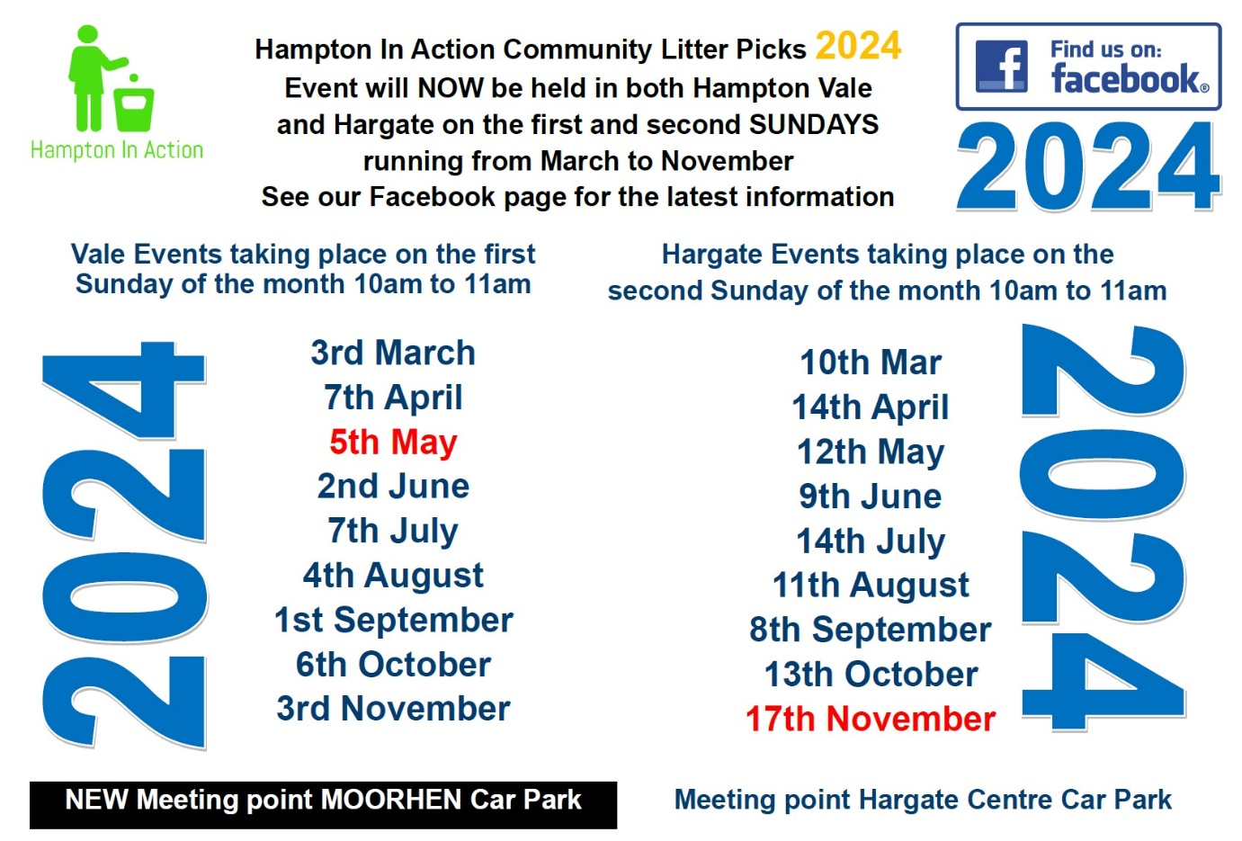  FOI Requests  I have received 3 FOI requests from the HV Chair regarding requesting a copy of the end of year Parish allotment accounts, Clerks job description and Clerks employment contract  The Contract will be retracted in parts (personal data) and the requests are being processed within the allocated time frame.  Business and Confidential – parish Council any elements of the contract
Close of Meeting 20:12

