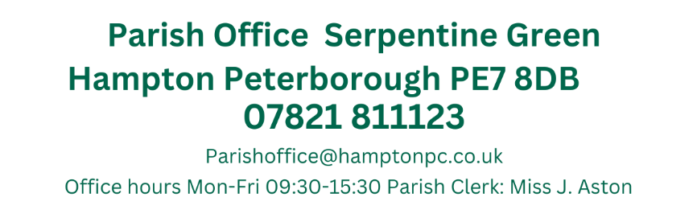

Present: Cllrs T. Fields, O’Sullivan, Otim, Patel, Pratt, Ryan, Sharp, & Wiggin (Chair)
14th March 2024
19:15
Active Hampton, Beaumont Way

MEETING OF THE PARISH COUNCIL

Members 10/14 (Quorum 5) Meeting was open to members of the public.
MINUTES
173/03-2024  19:15 | To receive apologies of absence
173/03-2024  19:15 | Apologies received from Cllr Toynton-Ward
174/03-2024  19:16 | Declarations of disclosable and/or pecuniary interest.
174/03-2024  19:16 | No Declarations of Interests regarding items on the agenda were received
175/03-2024  19:18 | Public Forum
175/03-2024  19:18 | A resident requested to know 2 year sof the pilot, is a 2 year pilot and will be assessed if this will continue, city wide or just the current areas. If selected licensing will also be incorporated to improve renting standards across the city
176/03-2024  19:33 | Ward Councillors Forum
176/03-2024  19:33 | Ward Councillor Wiggin Council stated Tax bills received by residents, it has been decided that the Regional pool will be demolished and replaced at a future date.  Hilton hotel – an offer has been received and considered to continue the build.
177/03-2024  19:43 | Approval of Minutes
177/03-2024  19:43 | Those who were present to receive and approve the minutes of the meeting held on the 1st February 2024  Present: Cllrs H.Fields, T. Fields, Otim, Patel, Toynton-Ward (Chair) & Wiggin  Proposed by Cllr Patel and Seconded by Cllr Otim  Members to also approve the minutes of the extraordinary meeting held on the 29th February  Present: H.Fields, T. Fields, O’Sullivan, Otim, Patel, Pratt, Ryan, Toynton-Ward (Chair) & Wiggin  Proposed by Cllr Ryan and seconded by Cllr Patel
178/03-2024  19:45 | Planning Application – Within the Parish
178/03-2024  19:45 | Members to comment on the following applications:  - Installation of 5 aircon units on the rear wall - retrospective  311 Eagle Way Hampton Centre Peterborough PE7 8GS  Ref. No: 24/00187/FUL | Validated: Tue 05 Mar 2024 | Status: Awaiting decision  No Noise assessment, would request that this is done before any decision is made. LP17  - Construction of a 3m rear extension, change of door to window at the front and change of use from 3no bedroom house (Class C3) to a 6no bedroom HMO (Class C4).  35 Molyneux Square Hampton Vale Peterborough PE7 8WA  Ref. No: 24/00246/FUL | Validated: Fri 23 Feb 2024 | Status: Awaiting decision  Objected on the basis of parking
179/03-2024  19:55 | Planning Application Outcomes – Within the Parish
179/03-2024  19:55 | Members to note the following decisions:  - Single storey rear extension.  28 Albert Crescent Hampton Vale Peterborough PE7 8JS  Ref. No: 23/01696/HHFUL | Validated: Fri 15 Dec 2023 | Status: Decided  No comments made/Granted
180/03-2024  19:56 | Signing of Publications
180/03-2024  19:56 | Members to view and approve the following document  Risk Assessment  Approved by all members.
181/03-2024  20:00 | Parish Elections
181/03-2024  20:00 | Clerk distributed the Parish Election nomination which were completed during the meeting.  Key Dates – nomination forms to be received by the 5th April
182/03-2024  20:15 | CIL Expenditure
182/03-2024  20:15 | During the February F&GP it was decided that the Parish Council should focus on street planters. Members discussed locations and designs of the street furniture ahead of requests for approval from PCC and O&H.  Members discussed that different planters were required for different purposes and that it should be decided if the planters are purely for decoration or as traffic management.  Clerk to enquire with PCC/O&H regarding a circular planter/bench near Vale primary school.
183/03-2024  20:30 | Bulky Waste
183/03-2024  20:30 | The Parish Bulky waste will be at the following locations on the 6th April  Hampton Library 10-12  Hargate Allotments 12-1pm (Members of the Public 12:30-1:00)  Vale Allotments 1-2pm (Members of the Public 1:30 -2:00)  Volunteers are required in each location to assist, data collection forms and hi-vis vests will be handed out at the April FC  Cllr Ryan and Clerk – Hampton Library  Cllrs Otim and O’Sullivan – Vale  Cllrs Fields and Fields – Hargate
184/03-2024  20:35 | Items for future agendas
184/03-2024  20:35 | Any submissions for future agendas need to be submitted on the online portal  Hampton Business Celebrations (TBC)
185/03-2024  20:36 | Clerks Report
185/03-2024  20:36 | Clerks Report – February/March  No report
186/03-2024  20:40 | Hampton Community Rooms
186/03-2024  20:40 | Due to the confidential nature of this agenda item, members of the public will be asked to leave during this agenda item.  Clerk and Cllr Patel updated members that a meeting is due to be held with HH Primary school on the 15th March
Close of Meeting 21:43

