
Present: Antunes, H. Fields, T. Fields, Otim, B. O’Sullivan, Z. O’Sullivan Patel, Sharp, Toynton-Ward (Chair) & Wiggin.

6th June 2024
19:15
Active Hampton, Beaumont Way

MEETING OF THE PARISH COUNCIL
Members 13/14 (Quorum 5) Meeting is open to members of the public.
MINUTES
021/06-2024  19:15 | To receive apologies of absence
021/06-2024  19:15 | Cllr Guyton, Pratt and Sharp sent their apologies
022/06-2024  19:16 | Co-option of Parish Councillors
022/06-2024  19:16 | Ward Councillor Antunes introduced himself and answered questions from the Parish Councillors.  Members voted in favour of Ward Councillor Antunes co-option.
023/06-2024  19:24 | Declarations of disclosable pecuniary interest.
023/06-2024  19:24 | A Declarations of Disclosable Pecuniary Interest regarding items on the agenda was received by Cllr Wiggin regarding item 026/06-2024.
024/06-2024  Learning  19:25 | Public Forum
024/06-2024  Learning  19:25 | Standing Orders will be suspended for the duration of the Public Forum.  .  Ian Richards (HHCAG) – stated that he is now on the job and would like to foster a good relationship with the Parish Council.  Kate Waller (HVCAG) Handed out a terms of reference and  service level agreement and would like work to be carried out on the new tanks, road repairs and new padlocks.  Kate Waller – Had a meeting with HH committee and raised concerns with the Clerk. Also concerned regarding the unfenced plots of 27/28  Cllr Patel raised a point of order that children should not be unsupervised on site.  Cllr Toynton-Ward stated that plot holders should be reported if their children are running around the site and reiterated that the Parish Council can not afford to commit on spending on all the work that the HVCAG committee would like and that this needs to be prioritised.  Clerk will purchase a new padlock and the outstanding matters will be taken to the F&GP Committee.
025/06-2024  19:40 | Ward Councillors Forum
025/06-2024  19:40 | Ward Councillor Wiggin stated that Ward Councillor Creste is now also the Mayor of Peterborough and that there is now a Labour led administration of the Council, Cllr Wiggin is in discussions with the new Deputy leader.  The Local plan process members meet every 5 years and the publication of the draft local plan will be released in September.  Ward Councillor Antunes stated that he is looking forward to getting to know the local residents and understanding and assisting with the issues in the area.
026/06-2024  19:50 | Approval of Minutes
026/06-2024  19:50 | Those who were present received and approved the minutes of the last meeting held on the 9^{th of} May.  Present: H. Fields, T. Fields, Guyton, B. O’Sullivan, Z. O’Sullivan Patel, Pratt, Ryan, Sharp, Toynton-Ward (Chair) & Wiggin  Proposed by Cllr Ryan and Seconded by Cllr Z. O’Sullivan
027/06-2024  19:52 | Planning Applications
027/06-2024  19:52 | Members commented on the following:  Demolish existing conservatory and erect a single-story rear extension  11 Tern Road Hampton Hargate Peterborough PE7 8DG  Ref. No: 24/00531/HHFUL | Validated: Wed 15 May 2024 | Status: Awaiting decision.  No comments made  Erection of 3 buildings with flexible uses: buildings C and D (class E(g), B2 or B8); building E (class E(g), B2, B8) or as a builder’s merchant together with associated parking and cycle storage  Land Adjacent To Unit B1 Club Way Cygnet Park Hampton Peterborough PE7 8JA  Ref. No: 24/00534/FUL | Validated: Thu 16 May 2024 | Status: Awaiting decision.  An appeal has been made to the Secretary of State against Peterborough City Council's decision to refuse to grant Planning Permission in respect of the following proposal:  Description: Change of use of first floor from residential to barbers and office use (Class E)  Address: 80 Hargate Way  Hampton Hargate  Peterborough  Reference: 23/01547/FUL  The Parish Council object to this application on the same basis as the original application
028/06-2024  20:07 | Planning Application Outcomes
028/06-2024  20:07 | To note:  (Application was validated on the 23^{rd of} May 2024)  Non-material amendment (floor plan layout change) pursuant to planning permission 23/00680/FUL  Unit 8B The Serpentine Green Shopping Centre The Serpentine Hampton Centre Peterborough PE7 8BE  Ref. No: 24/00692/NONMAT | Validated: Thu 23 May 2024 | Status: Decided  Extend existing first floor front elevation balcony and change first floor bedroom window to patio style door  161 County Road Hampton Vale Peterborough PE7 8ET  Ref. No: 24/00386/HHFUL | Validated: Mon 08 Apr 2024 | Status: Decided  No objections/Granted
029/06-2024  20:10 | Approval of Accounts
029/06-2024  20:10 | Members approved the following payments:  Petty Cash Items over £50.00  There have been no expenses over £50.00.  Proposed by Cllr Wiggin and Seconded by Cllr Otim
  JA00627 | 4045 | Nest Pension | No date assigned | DD |  | £106.93
  JA00628 | 4000 | J. Aston  Clerks Salary | ASAP | BACS |  | £1,706.64
  JA00629 | 4040 | HMRC Tax & NI  Contributions | ASAP | BACS |  | £457.71
  JA00670 | 4055 | Lengthsmen x2 (Peterborough Ltd) | ASAP | BACS |  | £6,123.46
  JA00671 |  | CaPALC/Nalc | ASAP | BACS |  | £1458.94
  JA00672 |  | SLCC | ASAP | BACS |  | £238.00
  JA00673 |  | Rialtas | ASAP |  |  | £230.40
  JA00674 |  | Petty Cash | 03/05/2024 | BACS (Preapproved) |  | £400.00
  TOTAL – Excluding Pre-approved items |  |  |  |  | £10,322.08
030/06-2024  20:12 | Hampton Vale Safety barriers
030/06-2024  20:12 | Safety barriers have been requested on plots 27/28 due to the water present on these plots.  The Clerk noted that the approximate measurement of the ¾ perimeter is 67 Meters.  1m high barriers may be a cheaper alternative that still provides safety on site.  29 of these (2.3m each) would be required for the 3 accessible sides.  Prices range from £522.00 (ebay) to £747.00 (fenceUk)  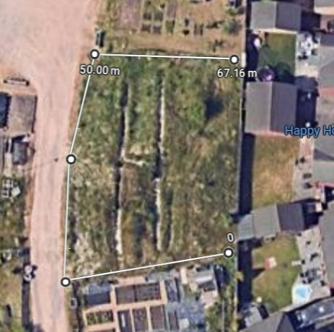    Members to discuss this cost and vote on any actions.  Order ASAP – cable ties strength  Warning signage deep water.  All members were in favour of purchasing the barriers up to the value of £747.00 and requested that this be done as soon as possible, including any additional small charge to accomplish this.
031/06-2024  20:27 | Allotment Finance
031/06-2024  20:27 | Due to the confidential nature of this agenda item, members of the public will be asked to leave during this agenda item.  Public Bodies (Admission to Meetings) Act 1960 1. (2)  Members discussed the allocation of allotment payments and decided that as the water payments had now stabilised at the HV site, that this matter should be re-assessed next year.
032/06-2024  20:40 | Items for future agendas
032/06-2024  20:40 | End of Year Accounts ASAP  Hampton Business Celebrations June F&GP02.13241 24
033/06-2024  20:41 | Clerks Report
033/06-2024  20:41 | Hargate Litter Pick  Hargate Primary school are holding a Big Picnic event on Saturday 8th June and have asked if Hampton in Action can attend to help with this. If any Councillors are available to attend, please meet at Active Hampton at 14:30.  Active Hampton bench  The family requested a different location, and so this has been referred back to PCC for a decision (17/05) and still awaiting confirmation  Hampton Hargate Community Room  There have been no additional discussions as Chris Pike has left that position and Felicity Paddick is now in charge of this. Still no information received  Active Hampton  Discussions are still being held between Active Hampton and the Football Foundation regarding the playzone project. Due to a huge increase in projected costs, this will now be a single pitch rather than a double.  PCC have still not provided a lease and Felicity Paddick has yet to contact any member of the AH committee.  Parish Website  The website hosting platform experienced issues from Monday to Wednesday evening and no files could be uploaded or the site republished. This issue has now been resolved.  SLCC Branch Meeting  Clerk is requesting to attend the SLCC branch meeting in Huntingdon on Friday 7th June.  Key speakers are attending from the Green flag awards and Anglia in bloom.  Cost to the Parish Council £8.10 return train fare.  Hampton in Action  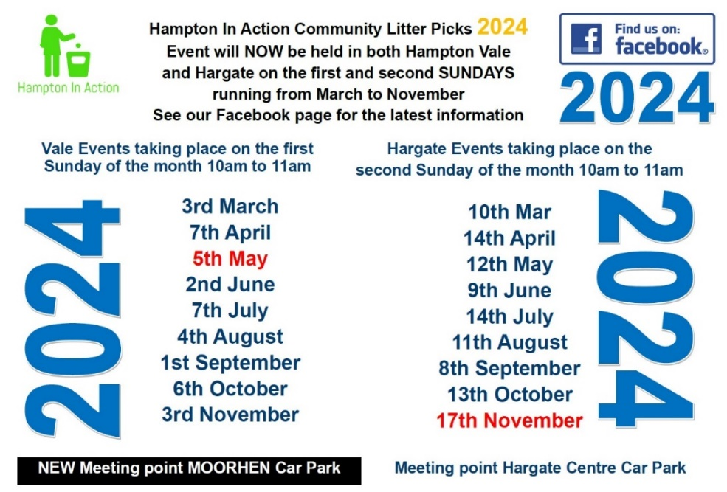
Close of Meeting 20:58

