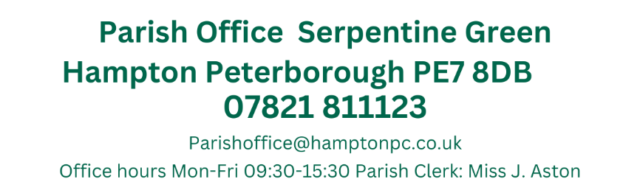
Present: Councillors Antunes, H. Fields, T. Fields, Guyton, Otim, B. O’Sullivan, Z. O’Sullivan Patel, Pratt, Ryan, Sharp, Toynton-Ward (Chair) & Wiggin.

11th July 2024
19:15
Active Hampton, Beaumont Way

MEETING OF THE PARISH COUNCIL
Members 13/14 (Quorum 5) Meeting is open to members of the public.
MINUTES
034/07-2024  19:15 | To receive apologies of absence
034/07-2024  19:15 | Apologies received from Cllrs Guyton and Ryan
035/07-2024  19:24 | Declarations of disclosable pecuniary interest.
035/07-2024  19:24 | No Declarations of Disclosable Pecuniary Interest regarding items on the agenda were received
036/07-2024  19:25 | Public Forum
036/07-2024  19:25 | 11 residents were present from Hornbeam Road who made the following statement;  “I am representing a lot of the residents in Hornbeam Road, we are a very small street with only 18 houses, our neighbourhood has upward of 10 children of school age and we need assurance that these children are safe to walk to school and play out, we are a close nit neighbourhood and this proposed institution does not fit with our community which is why we have all come together this evening as a whole to put our points across.  The renovation work at number 3 started about 2 months ago with internal doors replaced with fire safety doors, health and safety signs erected, new furniture in all rooms and decorating taking place, a majority of this work taking place in the middle of the night. I reported these renovations to the city council on the 15th June and on the 17th of June someone from the council made contact with the property.  Planning permission was then submitted on 20th June! I personally do not believe that planning permission was going to be applied for until they were caught out.  Last week more than 20 individuals and vehicles ascended on the property, it looked to be staff being shown around the house and the area. I myself have been inside the property and can confirm it is ready for its first occupants.  Data suggests that serious incidents involving the police and complaints are more common in private children’s homes run to make a profit than in homes run by charities and councils. There is a concern that these youths will lead to noise disturbances, antisocial behaviour and an increase in crime.  As a secondary teacher at a local school I deal daily with teenagers with SEN issues and behavioural problems and I know to well that it doesn’t matter how effective your behaviour policies are, you physically cannot control some situations and I see the impact that this has on an environment. I do not want to see this in the quiet pleasant area that we live in.  Another issue is parking, Hornbeam road is already problematic with parking and access especially at school drop off and pick up as Hampton Hargate primary parents regularly park along the street. Number 3 states on their existing site layout and design statement that they have 2 parking spaces at the rear of the property and a driveway to the front, this is a blatant lie as the property only has a drive with 1 parking space at the rear. Where will all the staff and carers park? What about the family and visitors? Number 7 has already had issues with their drive being blocked by cars from the property and other cars that have parked on the corners making visibility and access poor.  The impact that this institution will have on house prices is unfair on us owners in Hornbeam Road, perspective buyers will be put off and house prices will then reflect this. One resident has already checked with their house insurance company and if the proposal goes ahead there is a distinct possibility that house insurances prices will increase, how is this fair on us?  Questions-  Childrens commissioning have already asked to better understand the cohort of children that the house intends to offer, and we as residents want to know:  How many teenagers will be living at the property? I was told only 1 by the manager but another neighbour was told 2 and the proposal says up to 2. How many carers, I again was told 1 but the proposal states up to 4?  What special needs or behaviour problems could the teenagers have? If its mental health, are they a risk to themselves or others too? Are we at risk? Can anyone guarantee that we and our children won’t be at risk?  We are told that these teenagers cannot be homed in regular children’s homes or foster care, why not? How severe are they?  How long is the rental lease on the property?  We are aware that the current owner of number 3 also owns the adjoining property number 5 which is rented out, our concern is if the tenant of number 5 moves out, will number 5 be converted to join number 3 making a very much larger care institution?  As earlier stated, the property has completed the renovations already, staff members ready and waiting, to us residents this feels like it is already a done deal.  We kindly ask you to take into consideration our points of view when you review this application as the safety of our neighbourhood should not have to be compromised and I feel that if this planning application is approved, it is a risk we cannot afford to take”.  The chair thanked residents for attending and stated that Councillors aren’t allowed to directly respond to comments made in the Public forum, however, Ward Councillors could comment in the next agenda item and that the Parish Council would be discussing this application shortly and will look at the questions asked by the residents. The Clerk forwarded on the email addresses of the Ward Councillors present to the group representative  The Clerk Issued the email from the resident spokesperson to Cllr Wiggin and Cllr Antunes (the statement was not attached, but was delivered on 25th).  This Didn’t occur during the meeting and cannot be included
037/07-2024  19:40 | Ward Councillors Forum
037/07-2024  19:40 | Hampton Vale Ward Councillor Wiggin, stated that his intention is to object to the planning application within his ward and recommends that all residents make an objection regarding parking as only material amendments would be taken into consideration.  Cllr Antunes stated he is on the Planning committee for PCC and he can either remain unconnected with any resident action or become actively involved. In the latter he would require to step aside on the item and forego his planning committee vote he will look into the matter and report his decision in due course.  Vale Ward Cllr Antunes suggested this was a ‘Hargate Ward’ issue and Cllr Wiggins nor himself had direct responsibility.  The residents asked why no representatives form Hargate Ward were present. The Chair stated they were not members of the Parish Council.  Cllr Antunes suggested as they were also Peterborough First colleagues, he would alert them.  Cllr Wiggin also asked if the new Labour MP could be contacted to invite him to a meeting.  In Cllr Antunes Ward Cllr Report he stated:  It was a busy month, He was on this month’s Environment committee and had his ‘Recommendation’ unanimously supported by the Committee (Inc Cllr Wiggin) that the Council collect all fly tipping regardless of road adoptions. This resolution was the first step to a proposal which he was working on.  He confirmed he was also appointed the Combined Authority Scrutiny Committee, PCC Audit Committee and the Planning Committee.  His proposals for the Wildflower Planting of Nature’s Way and a community garden project had received support and plans were underway, which he would bring to Parish.
038/07-2024  19:50 | Approval of Minutes
038/07-2024  19:50 | Those who were present received and approved the minutes of the last meeting held on the May 6th 2024  Present: Antunes, H. Fields, T. Fields, Otim, B. O’Sullivan, Z. O’Sullivan Patel, Pratt, Toynton-Ward (Chair) & Wiggin.  Proposed by Cllr Otim and seconded by Cllr O’Sullivan
039/07-2024  19:52 | Planning Applications
039/07-2024  19:52 | Members commented on the following:  Change of Use from C3 (residential dwelling) to C2 (residential institution) for up to 2 children (aged 12-18)  3 Hornbeam Road Hampton Hargate Peterborough PE7 8FY  Ref. No: 24/00804/FUL | Validated: Thu 20 Jun 2024 | Status: Awaiting decision  Cllr Sharp – Restated that objections need to be submitted by any concerned parties regarding the material objection LP13 (Parking) and needs to focus on these.  Cllr Sharp also added that there are questions regarding the boundary and that the application refers to off street parking.  There is no precedent for approving or objecting applications  Cllr Wiggin stated directly to the residents that the fact that they have done a lot of work on the house doesn’t affect the process.  Cllr Pratt noted that PCC have a requirement to provide homes for children but residents need to focus on the material concerns  Cllr B O’Sullivan lives across from a similar home and ASBO and parking is an issue. Staff take up a lot of parking,  Cllr Otim stated that HPC need a policy if this becomes regular occurrence  Cllr Patel noted that there are no times indicated on the Parking survey and that there are inconsistencies within the report regarding the number of children who are being looked after.  The Parish Councillors decided to object this application based on the residents comments and those of the Parish Councillors and asked that this be called in to the Planning committee. Cllr Antunes abstained from the vote due to his potential conflict of interest.  Change of Use from C3 (residential dwelling) to C2 (residential institution) for up to 2 children (aged 4 to 17)  4 Swift Close Hampton Vale Peterborough PE7 8PW  Ref. No: 24/00819/FUL | Validated: Tue 25 Jun 2024 | Status: Awaiting decision.  For similar reasons listed in the previous application, this application will also be objected to and requested to be called into the planning committee.  It was an unanimous decision to object to both applications. Cllr Antunes again abstained due to his potential conflict of interest.
040/07-2024  20:10 | Planning Application Outcomes
040/07-2024  20:10 | To note:  Demolition of existing conservatory and erection of single storey rear extension to semi-independent residential home  1 Brickton Road Hampton Vale Peterborough PE7 8HS  Ref. No: 24/00432/FUL | Validated: Thu 04 Apr 2024 | Status: Decided  Granted
041/07-2024  20:12 | Approval of Accounts
041/07-2024  20:12 | Members approved the following payments:  Petty Cash Items over £50.00  Benn Lock and Safe (padlocks x 2) £185.70 02/07/2024  Benn Lock and Safe (5x keys for each site) £125.00 24/06/2024  Printed.com (HAA certificates for youth fishing) £79.41 17/06/2024  Proposed by Cllr Wiggin and seconded by Cllr O’Sullivan
  JA00675 | 4045 | Nest Pension | No date assigned | DD |  | £106.93
  JA00676 | 4000 | J. Aston  Clerks Salary | 04/07/2024 | BACS |  | £1,706.64
  JA00677 | 4040 | HMRC Tax & NI  Contributions | 04/07/2024 | BACS |  | £457.71
  JA00678 | 4055 | Lengthsmen x2 (Peterborough Ltd) | 04/07/2024 | BACS |  | £6,123.46
  JA00679 |  | CSK Church  Part ½ of Grant | 07/06/2024 | BACS |  | £1500.00
  JA00680 |  | Midway development (HV Barriers) | 13/06/2024 | BACS |  | £768.00
  JA00681 |  | Petty Cash | 24/06/2024 | BACS (Preapproved) |  | £400.00
  TOTAL – Excluding Pre-approved items |  |  |  |  | £8394.74
042/07-2024  20:15 | 2023-2024 AGAR
042/07-2024  20:15 | Clerk presented the AGAR for the 2024-2025 year to be signed by the Chair  End of year accounts had previously been viewed by the Full Council  All in favour
043/07-2024  20:20 | Hampton Gazette
043/07-2024  20:20 | Ms Clarke had submitted an additional offer to the Parish Council for articles within the Hampton Gazette;  200 words - £40.00 per month  350 words - £75.00 per month  Quarterly edit of 350 words - £29.00 per month  Members discussed these proposals and voted to instead focus on other means of disseminating information to residents.  Clerk to promote the email sign up
044/07-2024  20:30 | Allotment Matters
044/07-2024  20:30 | Due to the confidential nature of this agenda item, members of the public were be asked to leave during this agenda item.  Public Bodies (Admission to Meetings) Act 1960 1. (2)  Members discussed the service agreement plus outstanding matters.  The Parish Council will not agree to the service agreement based on the costs to plot holders and the Parish Council of implanting this.  The Chair stated that the Parish Council will look at options as and when they are presented as we need to be aware of ongoing costs  Cllr Antunes to have discussions with Anglia Water regarding the drainage issues and topsoil. The Parish would wish any solution to be fee.
045/07-2024  20:50 | Hampton Community Centres
045/07-2024  20:50 | The Hampton Vale Community Centre AGM was held on the 8th July  Hampton Parish Councillors B. O’Sullivan, Z. O’ Sullivan and the Clerk attended, although no invite was provided.  The AGM was not publicised to members of the public, statutory bodies or other group members who use the community centre in accordance with the adopted Constitution and tenants’ obligations.  There was no agenda placed in a prominent place at the Community Centre, in any public media, nor in Hampton generally (I personally checked this periodically over the 2 weeks prior to the meeting) nor was an agenda handed out or apparently available at the AGM.  The centre manager was present for the full duration of the AGM.  and only a brief overview of finances was presented with a number of omissions but no apparent information on including salaries was included, There were no discussions regarding approving an independent auditor of the accounts. This presentation did not appear to meet the requirements of the adopted Constitution.  It was estimated approximately 80 attendees’ were present at the AGM. to vote on any matters  There was no sign in sheet, thus no record of attendees and may not even live within the area of benefit and therefore should not be able to vote on any matters.  During the matter of any other business, I the Parish Council Clerk explained I had received a complaint from one Hampton resident who had booked the community centre for a 50th birthday party which had been cancelled due to the serving of alcohol  He responded that he had made the decision not to allow alcohol during bookings due a mess being made, and a toilet seat being broken. This was not apparently a committee decision.  The clerk went to ask when this decision was made? The centre manager and the chair both refused to answer this question.  The Centre manager went on to add the resident had agreed to this and later decided to complain, although he believes this was denied by the resident – This was not stated during the AGM  The centre manager confirmed that he had not communicated with the resident, although the resident had emailed and called.  The Clerk then asked had that this decision be put in writing to the resident.  The conversation was terminated by the Chair.  Clerk to amend notes for clarification and liaise with PCC
046/07-2024  21:05 | Items for future agendas
046/07-2024  21:05 | Nothing has been raised
047/07-2024  21:05 | Clerks Report
047/07-2024  21:05 | Active Hampton bench  This has now been approved by PCC and currently awaiting a fitting date  Hampton Hargate Community Room  There have been no additional discussions as Chris Pike has left that position and Felicity Paddick is now in charge of this. Still no information received  Active Hampton  PCC have still not provided a lease, however Felicity Paddick (PCC) has joined a recent meeting with the Football Foundation and the AH Committee, however this was unproductive and no further lease details were given.  The discussions around a single playzone pitch are still progressing and the next stage of this is the formal submission to planning.  Parish Bulky Waste  This will be held on the 7th September and is due to be discussed on the August Agenda, the preliminary times are stated below, please email if you can volunteer at one of the locations.  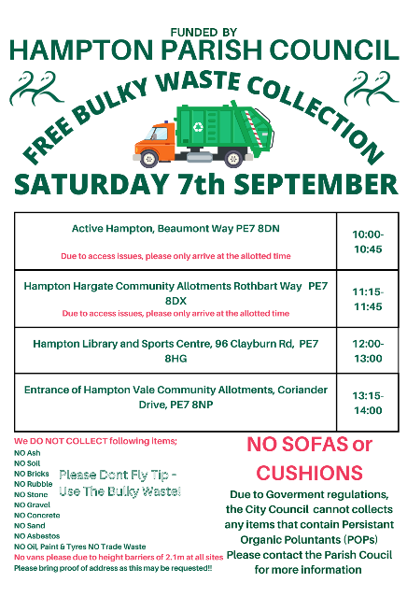  Hampton in Action  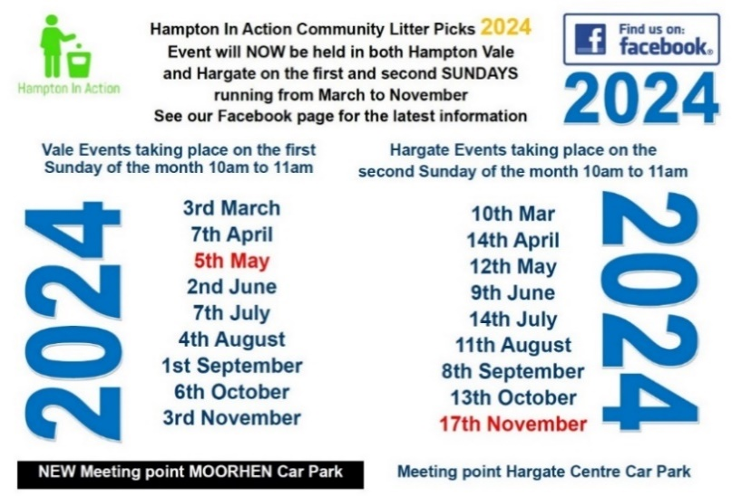
Close of Meeting 21:42

