
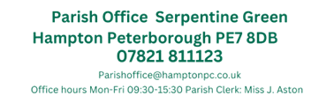
Present: Councillors T. Fields, O’Sullivan, Patel, Pratt, Ryan & Sharp
Online via Teams
Thursday 15th February 2024

Meeting of the Finance & General Purpose Committee
Members: 7 (9) Quorum: 3 Meeting was open to the public and press
MINUTES
FGP063-02/24  19:15 | To receive apologies for absence
FGP063-02/24  19:15 | Apologies received from Cllr Wiggin
FGP064-02/24  19:16 | Declarations of disclosable and/or pecuniary interest.
FGP064-02/24  19:16 | No declarations were received
FGP065-02/24  19:17 | Approval of the November F&GP Minutes
FGP065-02/24  19:17 | Members approved the minutes of the Finance and General-purpose committee held on November 16th 2023  Present: Councillors T. Fields, O’Sullivan, Patel, Pratt, Ryan & Wiggin  Proposed by Cllr O’Sullivan and seconded by Cllr Ryan
FGP066-02/24  19:19 | Public Forum
FGP066-02/24  19:19 | No members of the public were present
FGP067-02/24  19:29 | Ward Councillors Discussion
FGP067-02/24  19:29 | No comments received from Ward Councillors
FGP068-02/24  19:34 | Planning Applications
FGP068-02/24  19:34 | No applications as of 09/02
FGP069-02/24  19:34 | Planning Decisions
FGP069-02/24  19:34 | To note only:  3m single storey rear extension and use as 6no. person HMO  35 Molyneux Square Hampton Vale Peterborough PE7 8WA  Ref. No: 23/01727/CLE | Validated: Fri 22 Dec 2023 | Status: Decided  Withdrawn by applicant
FGP070-02/24  19:36 | Planning Applications – Outside the Parish
FGP070-02/24  19:36 | No pertinent applications since 09/02
FGP071-02/24  19:36 | Planning Decisions – Outside the Parish
FGP071-02/24  19:36 | No pertinent decisions since 09/02
FGP072-02/24  19:36 | Bulky Waste Collections
FGP072-02/24  19:36 | The following have been received from PCC along with a Calendar of available bulky waste collections.  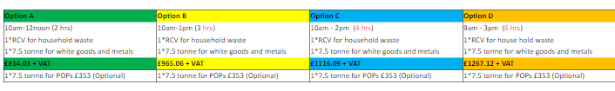  The 2023 cost for the usual 4 hours was £824.95 + VAT and the 2024-2025 budget for Environmental expenditure is £3500.00, to be taken from reserves.  Members voted to book two bulky waste collections and discuss a third later on in the year. Members requested April 6th and September 28th – both for Option C (4 hours)  All members were in favour of this.
FGP073-02/24  19:46 | Change of Meeting Date
FGP073-02/24  19:46 | A survey had been sent to members regarding potentially changing the date of the March Full Council meeting. The majority (6) voted to change the March FC to the 14th.  All members were in favour
FGP074-02/24  19:51 | CIL Report Discussions
FGP074-02/24  19:51 | A survey was been sent to ask members which public proposals are to be discussed in more detail.  Councillors voted:  Bridge near the outdoor gym 4  Lights around St James Pond 5  Street Planters 6  Dog Park 1  Clerk to look in more details and find viable options for Street planters and lights around James Pond.
FGP075-02/24  20:06 | Office Internet Connections
FGP075-02/24  20:06 | Clerk presented a list of quotes to provide an internet connection within the Parish Office.  The two options were a fixed line at a cost of £35.00 per month or a portable Wi-Fi device at £30.00 per month. Members proposed that a portable Wi-Fi device may be the better option and Clerk to purchase this and test speeds within the 14 day cooling off period.
FGP076-02/24  20:15 | Allotment Finance
FGP076-02/24  20:15 | Due to the confidential nature of this agenda item, members of the public will be asked to leave during this agenda item.  Clerk and Cllr Patel discussed the Allotment Finances  It was proposed that the allotment rental fees for the 2024-2025 period  Full plots - £45.00  Half Plots - £23.00  Quarter Plots - £12.00  Mini Plots - £6.00  This will be taken to the Full Council for a decision ahead of the April renewals
CLOSE OF MEETING 20:54

