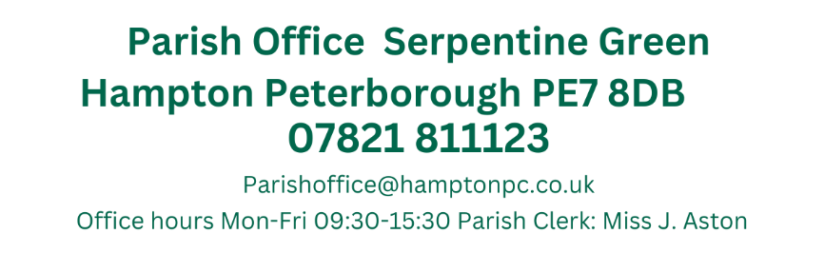
Preset: Councillors Antunes, H. Fields, T. Fields, B. O’Sullivan, Z. O’Sullivan, & Wiggin (Chair).
1st August 2024
19:15
Active Hampton, Beaumont Way

MEETING OF THE PARISH COUNCIL
Members 13/14 (Quorum 5) Meeting is open to members of the public.
AGENDA
048/08-2024  19:15 | To receive apologies of absence
048/08-2024  19:15 | Apologies received from Councillors from Guyton, Otim, Patel, Pratt, Sharp and Toynton-Ward
049/08-2024  19:16 | Declarations of disclosable pecuniary interest.
049/08-2024  19:16 | No Declarations of Disclosable Pecuniary Interest regarding items on the agenda were received.
050/08-2024  19:17 | Public Forum
050/08-2024  19:17 | Mike Horne from the Langdyke Countryside Trust was present to discuss plans in Hampton to plant flowers on the area to the south of Serpentine Lake and Natures way, which will include a 2 meter strip on either side of a pedestrian/cyclist path 18 species of wildflowers are present on the sites currently and this scheme will add to this.  Ward Councillor Antunes has already been in discussions with Mr Horne and would like to involve the schools and other local groups.  A Working party for this project was approved
051/08-2024  19:32 | Ward Councillors Forum
051/08-2024  19:32 | Councillor Antunes added further information regarding the wildflower project. He would like to take this to public consultation, possibly in September. O&H and Anglia water are already onboard with the scheme and Nene gate school are already involved in the discussions. Cllr Antunes added that this would be a pilot scheme and if successful would be launched in other areas within Hampton.  Cllr Antunes also stated he will stand down at the planning committee so he can represent residents (regarding the Swift Close applications) However there is no date for the committee hearing as yet.  Cllr Antunes also stated about the potential for a GP surgery, and is in meetings regarding this, his meeting with Felicity Paddick (PCC) regarding the assets review which is looking into 80+ assets in Peterborough.  Cllr Antunes also held a meeting with I Phillips (PCC) regarding the Vale community centre, who will be looking into the workings of the Community centre and will invite the HVCC manager to a future meeting.  The proposal by Cllr Antunes for PCC to collect all flytipping regardless of adoption status is working through the channels and he is positive that it will be passed in the future.  Councillor Wiggin stated that he has spoken to residents of Swift Close and is supporting them in their objection to the recent planning application. Cllr Wiggin also removed flytipping from Eagle Way.
052/08-2024  19:42 | Approval of Minutes
052/08-2024  19:42 | Due to last minute amendments, the minutes will be proposed at the next meeting.
053/08-2024  19:43 | Planning Applications
053/08-2024  19:43 | Members commented on the following:  37 Mid Water Crescent Hampton Vale Peterborough PE7 8JT  Ref. No: 24/00953/HHFUL | Validated: Tue 23 Jul 2024 | Status: Awaiting decision  No comments made
054/08-2024  19:52 | Planning Application Outcomes
054/08-2024  19:52 | To note:  Proposed rear single storey extension and garage conversion  88 Lakeview Way Hampton Hargate Peterborough PE7 8DQ  Ref. No: 24/00722/HHFUL | Validated: Tue 04 Jun 2024 | Status: Decided  No objections/approved  Demolish existing conservatory and erect a single story rear extension  11 Tern Road Hampton Hargate Peterborough PE7 8DG  Ref. No: 24/00531/HHFUL | Validated: Wed 15 May 2024 | Status: Decided  No objections/approved  Demolition of conservatories and replace with rear ground and first floor extensions  8 Willow Holt Hampton Hargate Peterborough PE7 8AP  Ref. No: 24/00529/HHFUL | Validated: Mon 22 Apr 2024 | Status: Decided  No objections/approved
055/08-2024  19:55 | Approval of Accounts
055/08-2024  19:55 | Members approve the following payments:  Petty Cash Items over £50.00  No items over £50.00  Proposed by Cllr Z. O’Sullivan and Seconded by Cllr Ryan
  JA00682 | 4045 | Nest Pension | No date assigned | DD | £106.93
  JA00683 | 4000 | J. Aston  Clerks Salary | ASAP | BACS | £1,706.44
  JA00684 | 4040 | HMRC Tax & NI  Contributions | ASA | BACS | £457.91
  JA00685 | 4055 | Lengthsmen x2 (Peterborough Ltd) | ASAP | BACS | £6,123.46
  JA00686 |  | Petty Cash | 29/07/2024 | BACS (Preapproved) | £400.00
  TOTAL – Excluding Pre-approved items |  |  |  |  | £8394.74
056/08-2024  19:57 | Hampton Bulky Waste Collection
056/08-2024  19:57 | The next collection will be held on the 7th September. As football matches will be on at Active Hampton a 9am start was requested and accepted.  The following times have been approved by all members  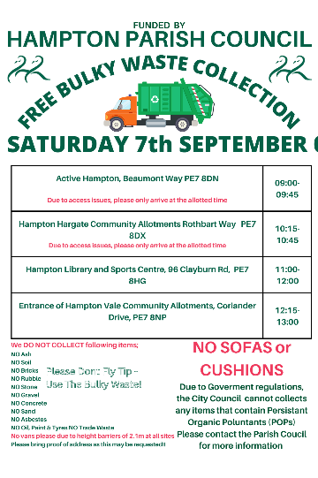  Volunteers confirmed for each site  Active Hampton Cllr Patel & Cllr Wiggin  Hargate Allotments Cllr Fields & Cllr Fields  Hampton Library J. Aston & Cllr Ryan  Vale Allotments Cllr Sharp &
057/08-2024  20:10 | Stewartby Avenue One-way system
057/08-2024  20:10 | A number of residents have been in touch to complain about cars continuing to travel the wrong way through the one way system.  Members discussed that additional signage is needed and Clerk to contact the school regarding sending an email to all parents.  Clerk to also contact PCC regarding trimming the bushes next to the HVCC  Cllr Antunes also stated that he would like Stewartby Avenue to be closed off to traffic and become a parking area and has had discussions with residents regarding this.
058/08-2024  20:20 | Temporary Grant Request
058/08-2024  20:20 | Ward Councillor Wiggin is funding the memorial garden stones and requires an invoice in advance. The request for clerk to purchase these items on Cllr Wiggins behalf and receive the CLF funding once this has been submitted was approved by all members.
059/08-2024  20:25 | Items for future agendas
059/08-2024  20:25 | 2024 Financial Regulations – Sept FC  HV/HAA Plan – Sept FC  Recreations Meeting – 11th September (Online)
060/08-2024  20:27 | Clerks Report
060/08-2024  20:27 | Active Hampton bench  This has now been installed at Active Hampton and awaiting the installation invoice (this is covered by the VAT paid by the family for the bench)  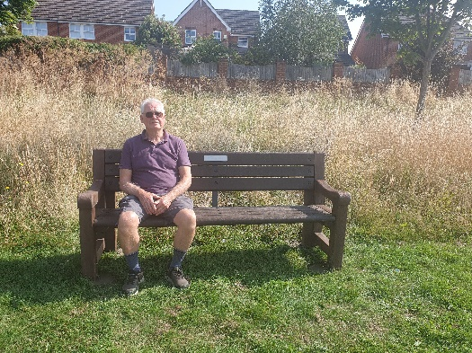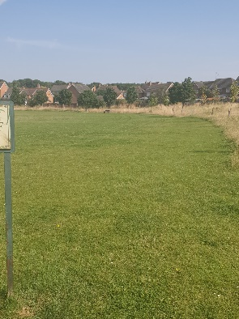  Hargate Ward Councillors  Ward Councillor Howard sent the following email asking this to passed on to members “I just wanted to confirm as the three Ward Councillors, myself, Saqib and Farooq have called-in this planning application for change of use for 3 Hornbeam Way”  Councillor Training  A training session provided by the PCC to assist Parish Councillors and Co-opted Members with code of conduct issues and register of interests, will be held on Thursday, 26 September 2024 from 5:30pm. A number of Councillors have already signed up to this and if you wish to attend, please let me know.  Hampton Hargate Community Room  There have been no additional discussions as Chris Pike has left that position and Felicity Paddick is now in charge of this. Still no information received  Active Hampton  PCC have still not provided a lease and the football foundation have emailed PCC to state that unless a lease is received soon that the playzone project will be cancelled  Hampton Angling Associaton  A family in Hampton have been refused permission  receive membership books, this is due to the youths injuring swans and the parent assaulting the HAA Chair. A complaint from the family may be received.  Hampton in Action  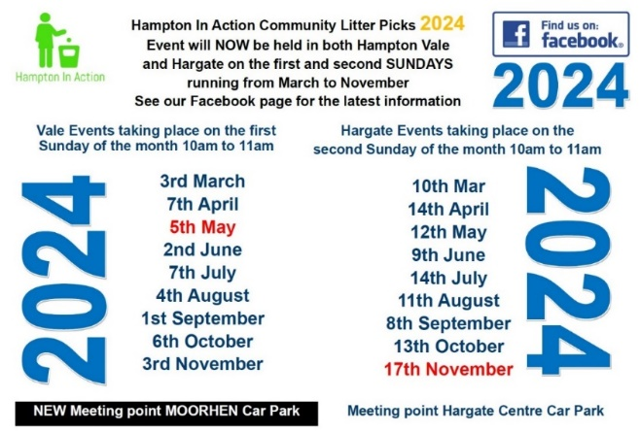
Close of Meeting 21:09

