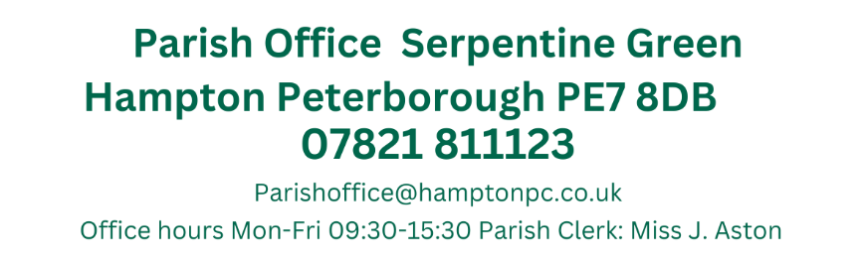

Present: Cllrs Otim, Patel, Ryan, Sharp, Toynton-Ward (Chair) & Wiggin.
4th April 2024
19:15
Active Hampton, Beaumont Way

MEETING OF THE PARISH COUNCIL
Members 10/14 (Quorum 5) Meeting was open to members of the public.
MINUTES
187/04-2024  19:15 | To receive apologies of absence
187/04-2024  19:15 | Apologies sent in advance by Cllrs H. Fields, T. Fields, O’Sullivan and Pratt
188/04-2024  19:16 | Declarations of disclosable and/or pecuniary interest.
188/04-2024  19:16 | No Declarations of Interests regarding items on the agenda have been received
189/04-2024  19:18 | Public Forum
189/04-2024  19:18 | 3 Public comments received  Mr Nutley Regarding Peterborough First using HPC in literature, Mr Nutley has complained to the monitoring officer and Cllr Farooq has sent an apology however Mr Nutley would like HPC to write to the City Council in a formal letter of complaint. Mr Nutley also sent an FOI request regarding this matter which was dealt with promptly  Members decided to Vote on complaint:  Not going to complain as the complaint has already been dealt with: 4  Those wishing to complain: 0  2 abstentions  Mr Dontoh raised that parking on the verge seems to be permitted here, which is causing damage. This behavior not only ruins the verge but also burdens the council with repair costs. Verge areas are typically not meant for parking. Are there any plans to address this issue, perhaps by making parking on the verge illegal?  Cllr Wiggin stated that guidance on verge and kerb parking includes a petition signed by residents and no-one else in Hampton has taken this step. Clerk to advise resident to use Vale drive as a case study.  Mr Bisby-Boyd raised the following: An attack in Hampton skate park around 6/7pm on Wednesday 3rd April a teenager was attacked by at least 2 or 3 boys apparently from Orton. A bloke stopped to check on him apparently. He has no recognition of the event or even remember getting home an ambulance was required to take him to hospital.  Are the Parish Council going to hold request neighbourhood team for the South of Peterborough attend Parish Council meetings to hear feedback and engage with the Parish Council. Are the meetings being held on Zoom online anymore? If not then they should be allowed so more residents can engage from their homes due to family and work commitments.  Invite neighbourhood policing team – invite to meeting.  Resident: Voicing concern regarding her son who was assaulted at the Skate Park, would like to know if the Parish Council can do anything to protect the youths in the area.  Chair cannot comment on an active investigation – should approach the council with regard to CCTV in the area.  Cllr Ryan – The skate park is a benefit to those in Hampton and reiterated that there is an issue with CCTV in the area. Cllr Ryan questioned if there is a wider social issue in the area and how we can offer deterrents in the area. Has been low level ASBO in the area  Chair – Lack of Policing in the area compared to a number of years ago and projects have waned over the years.  Cllr Wiggin Safer Peterborough Partnership, Conjoined working, reporting is a must to highlight the issues.  Resident: Regarding the road issues and increase in fees (Hampton Vale Allotments)  Little miracles plot – needs new fence, this is discouraging Parents – interim period to have a more fenced off period. Constant flooding to the rear of the plots. Safety issues.  Recreations meeting – dates in advance / Heris fencing.  Service level agreement and Terms of reference  Road rectification – needs another discussion.  Members will discuss this at a later date.
190/04-2024  19:33 | Ward Councillors Forum
190/04-2024  19:33 | Ward Councillor Sharp – Active Hampton - Camera is live and is functioning however discussions with Police and PCC no-one knows where it is being monitored. Active Hampton were never instructed on the camera.  Cllr Wiggin – Roadworks at J3 are finished, one issue regarding the lanes and this is being looked at  Cllr Patel asked about the Development on Silver Hill Parking bays – one of the stipulations agreed was that the parking bays were meant to be duplicated however during the building process these bays have already been lost. Ward Councillor Wiggin will look into this.
191/04-2024  19:43 | Approval of Minutes
191/04-2024  19:43 | Those who were present received and approved the minutes of the meeting held on the 14^{th of} March 2024  Present: Cllrs T. Fields, O’Sullivan, Otim, Patel, Pratt, Ryan, Sharp, & Wiggin (Chair)  Proposed by Cllr Ryan and Seconded by Cllr Otim
192/04-2024  19:45 | Planning Application – Within the Parish
192/04-2024  19:45 | No pertinent applications as of 28/03
193/04-2024  19:45 | Planning Application Outcomes – Within the Parish
193/04-2024  19:45 | No decisions have been made as of 28/03.
194/04-2024  19:45 | Approval of Accounts
194/04-2024  19:45 | Members approved the following payments:  Proposed by Cllr Ryan and Seconded by Cllr Otim
  JA00616 | 4045 | Nest Pension | No date assigned | DD |  | £106.93
  JA00617 | 4000 | J. Aston  Clerks Salary | ASAP | BACS |  | £1,706.64
  JA00618 | 4040 | HMRC Tax & NI  Contributions | ASAP | BACS |  | £457.71
  JA00619 | 4055 | Lengthsmen x2 (Peterborough Ltd) | ASAP | BACS |  | £5701.08
  JA00620 |  | Petty Cash | 21/03/2024 | BACS (Preapproved) |  | £300.00
  TOTAL – Excluding Pre-approved items |  |  |  |  | £7972.36
195/04-2024  19:47 | Hampton Vale One-Way System
195/04-2024  19:47 | 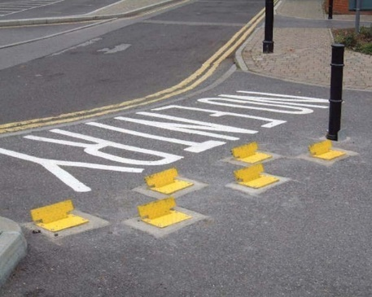  The one-way system still is causing some confusion; therefore, it has been suggested that traffic control plates could be installed at the exit point of the one-way system to deter drivers from ignoring the one-way system. CIL funding could be used for the implementation of this.  Cllr Sharp is unsure if Highways would allow this, Cllr Wiggin suggested that ANPR would be a be a better alternative  Cllr Ryan states that there still isn’t significant signage  Clerk to ask Highways to review the signage, possibly a no turn sign and mobile ANPR
196/04-2024  20:00 | Hampton Community Rooms
196/04-2024  20:00 | Clerk and Cllr Patel presented a viability plan for the Hampton Hargate community room.  Members  Cllr Otim – Would be good to see if a 3 month trial would work for the community  Cllr Wiggin – concerns over finding a care taker and may be available in the interim period  Cllr Ryan would like to offer this as a pilot to see if it is viable,  Cllr Sharp – would like more figures regarding costs, forecasting and would like assurances that we can cover costs – needs to know that there is the business need for this.  A vote was held by members:  5 members voted Yes to a 6 month trial  1 members voted no as we should know the ongoing costs.  Clerk to arrange additional meetings with C. Pike to discuss ongoing costs and look at current groups who may want access to the room.
197/04-2024  20:20 | Signing of Publications
197/04-2024  20:20 | Members to view and approve the following document.  - Asset register - Delayed to later meeting
198/04-2024  20:22 | Bulky Waste – Reminder
198/04-2024  20:22 | Clerk distributed the data collection sheets and hi-vis vests for those volunteering.  The Parish Bulky waste will be at the following locations:  Hampton Library 10-12 – Cllr Ryan and Clerk  Hargate Allotments 12-1pm (Members of the Public 12:30-1:00) Cllrs T. Fields & H. Fields  Vale Allotments 1-2pm (Members of the Public 1:30 -2:00) Cllrs Otim and O’Sullivan
199/04-2024  20:25 | Items for future agendas
199/04-2024  20:25 | Any items for future agendas need to be submitted on the online portal.  Hampton Business Celebrations (TBC)  End of Year Accounts (May/June)
200/04-2024  20:26 | Clerks Report
200/04-2024  20:26 | Clerks Report March  Hargate one stop bin  Despite continuous emails to one stop head office, the bin has not been replaced – therefore I have advised their media and legal department that I will be notifying the local press. The HH lengthsmen has been sending me pictures and I will be contacting the Peterborough telegraph  Active Hampton Bench  As previously discussed, the Memorial bench at Active Hampton has been paid for by the family and the design has been approved, currently waiting on a delivery date.  J3  All works have now been completed and I have not received any complaints regarding this matter  Parish Elections  The forms have been submitted, I should be notified early next week if we a subject to an election.  Parish Grant Request  CSK have contacted me to ask if the Parish Council would be interested in supporting their food support hub which provides warm meals to local residents in need. Full details of this will be on the May agenda  Parish Internet  Peterborough Cars have kindly shared their WIFI codes with the Parish Council and so far this is working for everything that is required at the office.  With the Chairs permission is may be kind to offer a token of thanks to Peterborough cars
Close of Meeting Estimated 21:12

